***Title:***

***The ShoeRoom individual report***

***Name:***

***Tran Hoang Hai Anh***

***Student ID:***

***104177513***

***Index:***

***1.Introduction***

***2.Website description***

***3.Website map***

***4. Website style***

***5. Key feature***

***6. My contribution***

***7. Conclusion***

**1.INTRODUCTION**

Our website is written in HTML and CSS. Our team tried our best to create a great website for our project. Our website is designed to be very user-friendly and packed with great graphics and demonstrations for our products. Our team understands that a great website is a website that is simple for every internet user. The objective of this report is to demonstrate how our website works as well as our contents and the reason behind why we chose this product. Through HTML and CSS, we want to provide a webpage that meets our assignment requirements as well as a result of our hard work teamwork project. My report will be divided into 5 main parts: Introduction, website description, my contribution, conclusion, and appendix.

**2.WEBSITE DESCRIPTION**

The first website is an index page where we place a large banner on our website to advertise the current promotion and discounts. As for placing our sales banner, we used a div called="adbox" and the <img> markup to insert our jpg image. In my opinion, it is very important to send an eye-catching message or banner on the front page as it can influence the decisions of the buyers a lot. Below are some of our new shoes in our collection as they can be classified as a new arrival which can influence the buyers who want the latest and highly fashioned shoes. We called a div called "featured", as we use ul and li to place our images in a horizontal list. We put a large "shop here !" button as it links to our main shop page to create convenience for our customers by using a hyperlink that redirects to our shop website and we identified it as a class "button" for later styling in CSS. The next website is about us, this website is where the customers can understand more about our business, our missions as well as values, an explanation for the reasons why this website is created and what our goals are, and our sales motto. Our group created a division called "content" for our content, we use h1 markup for headings and p markup for our text content. Under those texts, we also decorated some of our great-looking shoes with ul and li markups as well as a hyperlink button the same as on our previous page. The following page is our product page, which contains information and pictures of our products, it includes the available sizes, materials, gender as well as prices for our shoes. In that section, we used ul and li for the images to be aligned horizontally and on a pre-chosen margin and padding. On the right side, there is our short message which advertises our shoes' practicality and fashion which can be worn everywhere. We used aside markup for our short message which appears right next to our shoes as it can influence the decision of our customers. We also created a small table that can be useful for converting shoe sizes from different units. In the table, we used elements such as th and td combined with some CSS to make it look balanced and centered. The enquire page is our next page as required, this part we created a form to get the information from the users they wish to know about our products. This page in my opinion is very crucial, as it can allow customers to ask us questions, understand our customer's expectations, and needs, and improve our product quality. This form we created solely based on our requirement for this assignment, all parts of our form strictly followed the rules and patterns for each element of this form such as type, maximum and specific patterns. At the end of the form, we put a submit and a reset form button to test the data extracted from the page to the Mercury form test website. The last page is where we leave our personal information, it was created using dl, the definition list, and there are our profile pictures inside the "figure" markup. Under our personal information are our study timetables which were created by table, tr, th, td and altogether were put into a fieldset each individual to make it less complicated to look at. In the head part, our team put a logo image as a hyperlink so that when it is clicked, it will return to the homepage or the index page like other websites as well as hyperlinks to other websites to design a great organized nav bar. A great navigation bar makes it simple for customers to locate what they're searching for on the website, which is a crucial component of the user experience. It helps people rapidly and simply navigate the website and discover the necessary material. Visitors who have trouble finding what they're searching for or are confused by a badly designed navigation bar may become dissatisfied and leave the website. On the footer part, our team uses div "description" to give an overall view of why our team created this website by using "p" markup. At the bottom of each page, there is also a navbar that can be used to change pages more conveniently after customers have scrolled to the end of the page.

**3.Website map**

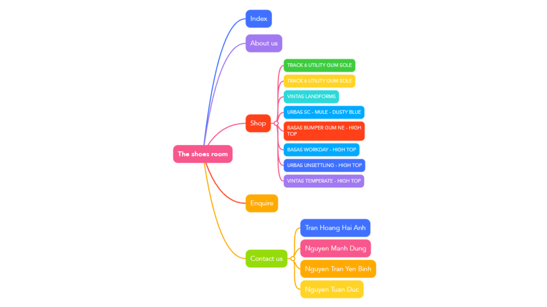

**4.Website style**

At The Shoesroom, we recognize the value of a visually appealing website. Our website has a clear, contemporary, and eye-catching design that improves the browsing and purchasing experience for customers. We have organized our banners at the top of most of each website to catch more attention from customers. On the home page, the navigation bar is aligned by "display: block" combined with width and height to reach our predetermined location on our page. These navigation buttons are decorated by class "selected" which will highlight which page is currently at or chosen.

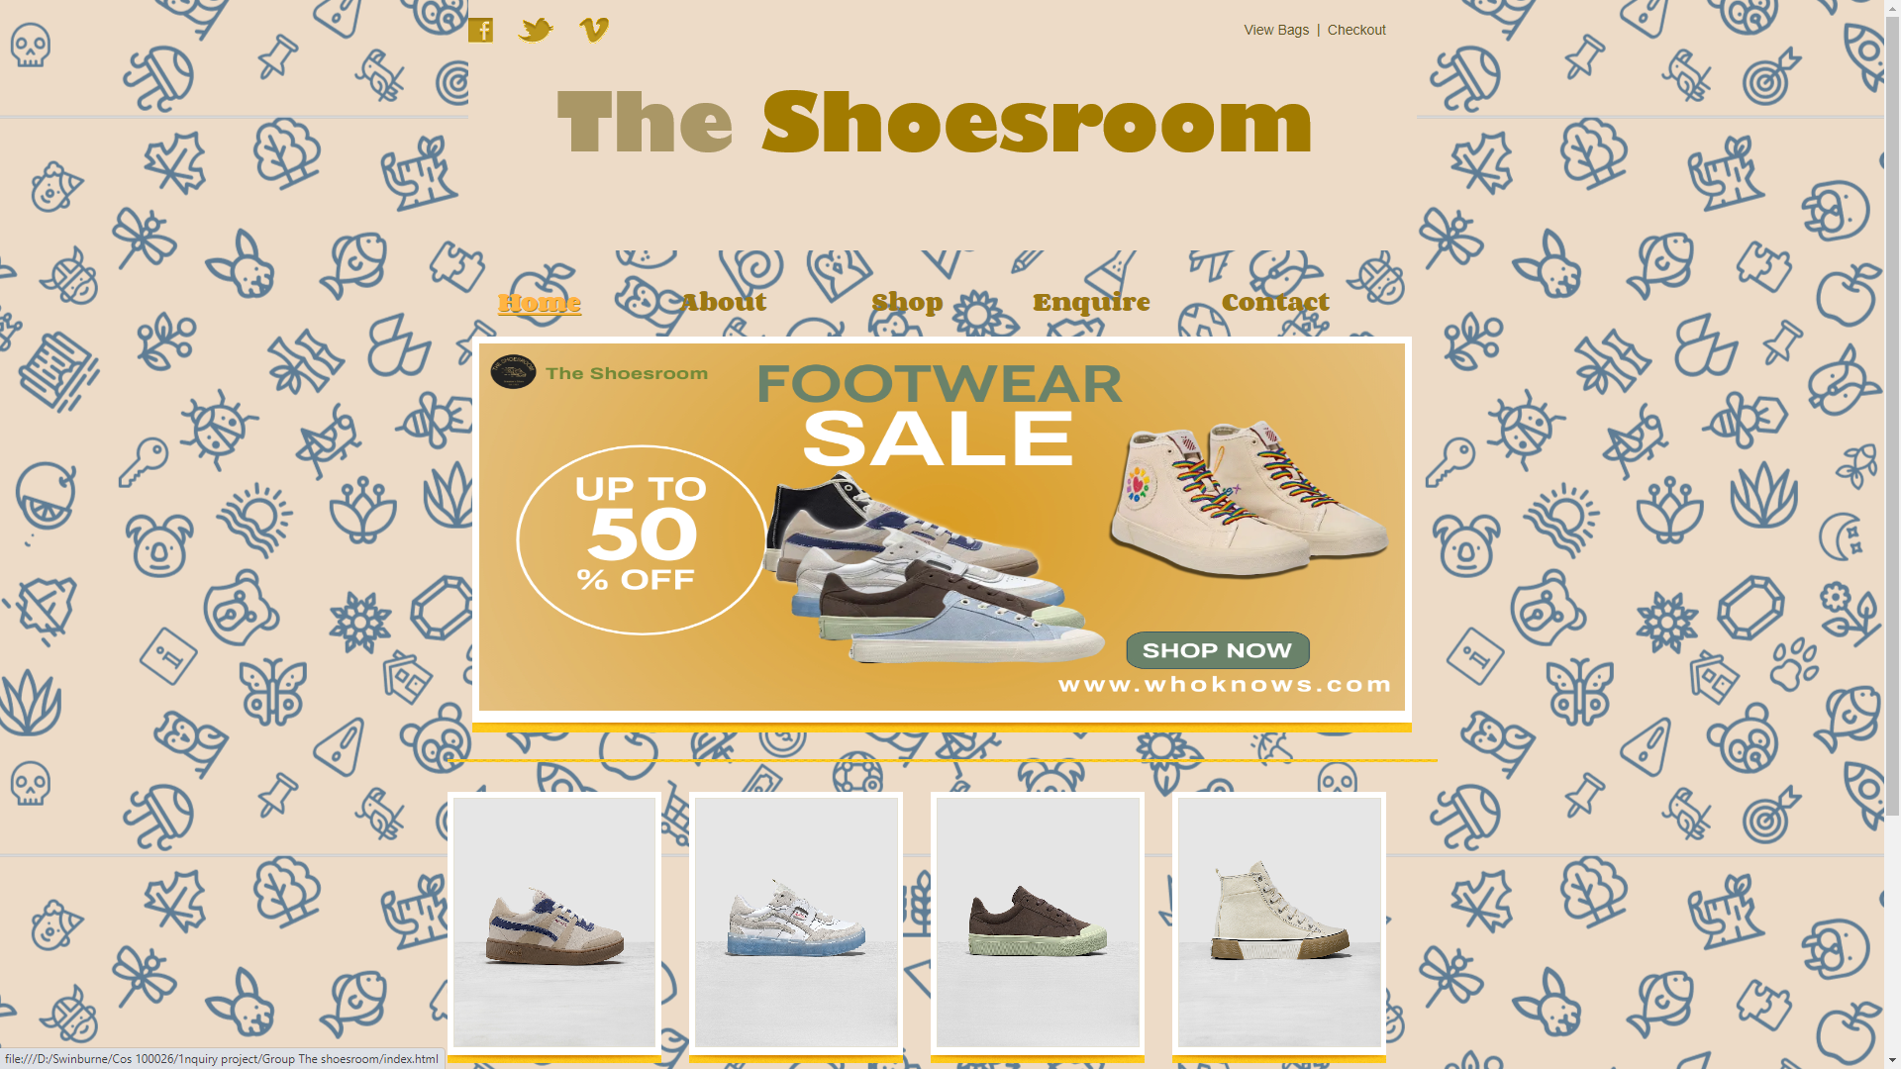

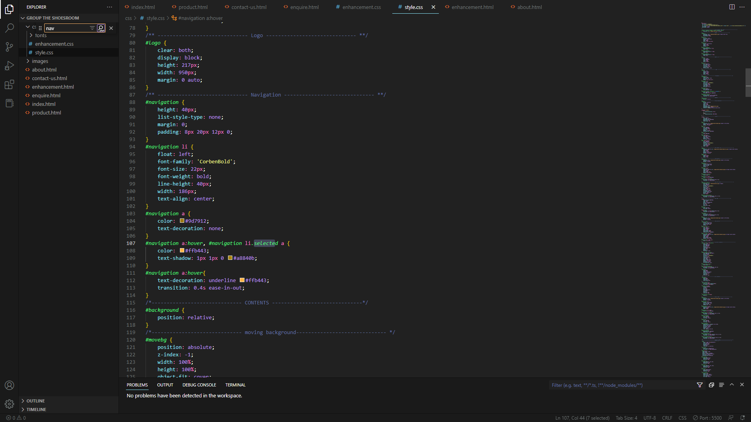

Pointing or hovering each option will also underline with "text-decoration: underline" as we created using a pseudo-class hover for stylish. Under this is an advertisement identified as "adbox", we used height, width, margin, and padding to correctly place the image where we had wished. A "shop here" button is styled with a dark color using "color:", a font called "Corden bold '' as well as many position and size markups such as font size, height, padding, and position. The next page is about us so we mainly used markups h1 and p to write a short paragraph introducing our missions and aims etc. The next shop page is where we used many css lines to create a great-looking website like that. First of all, we lined up those shoe images using ul, li to list them unordered horizontally with a display:inline-block for the same row, list-style-type none for no unwanted icons. We also aligned spans to keep space from our product images and information. The "shoe_img" class combined with hover and not pseudo-class creates that blurring with text on display effect. When hovering over it, a filter blur will be applied and lowered the brightness to 60% with a box shadow effect. To display text, we use position absolute, z index to place it over the first blurring effect layer, and opacity 0 to make it more transparent.

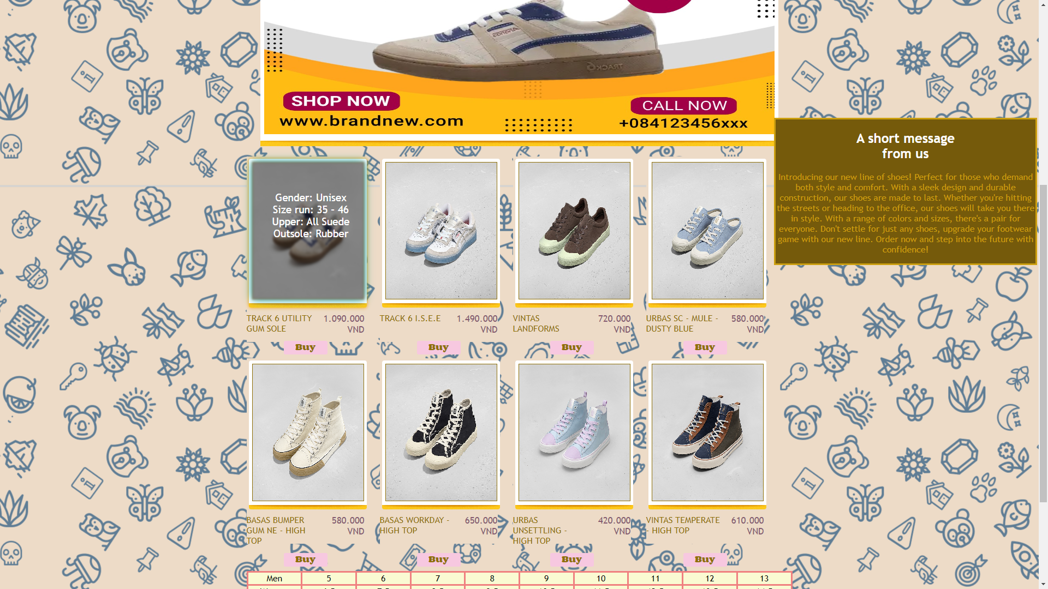

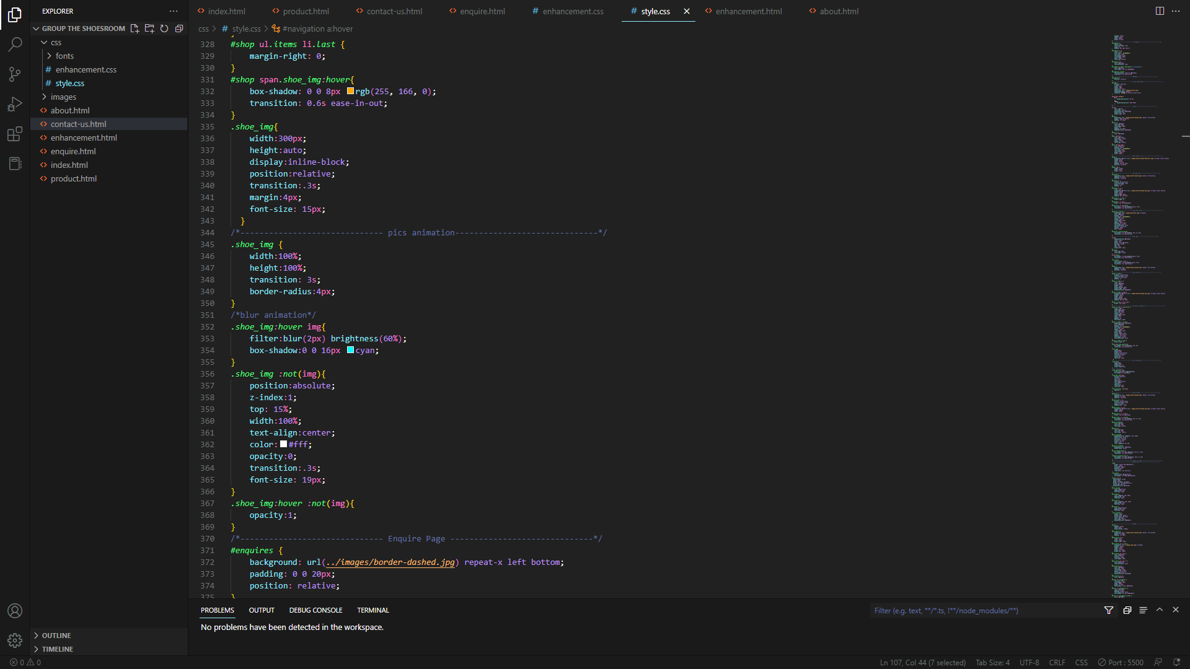

The enquire page also has the hover shadow effect as it has box-shadow and transition. The fieldset was decorated with a background with color, and a solid border with border-style and color for the text at this fieldset. The fieldset also has some shadow effect when hovering over parts in this fieldset.

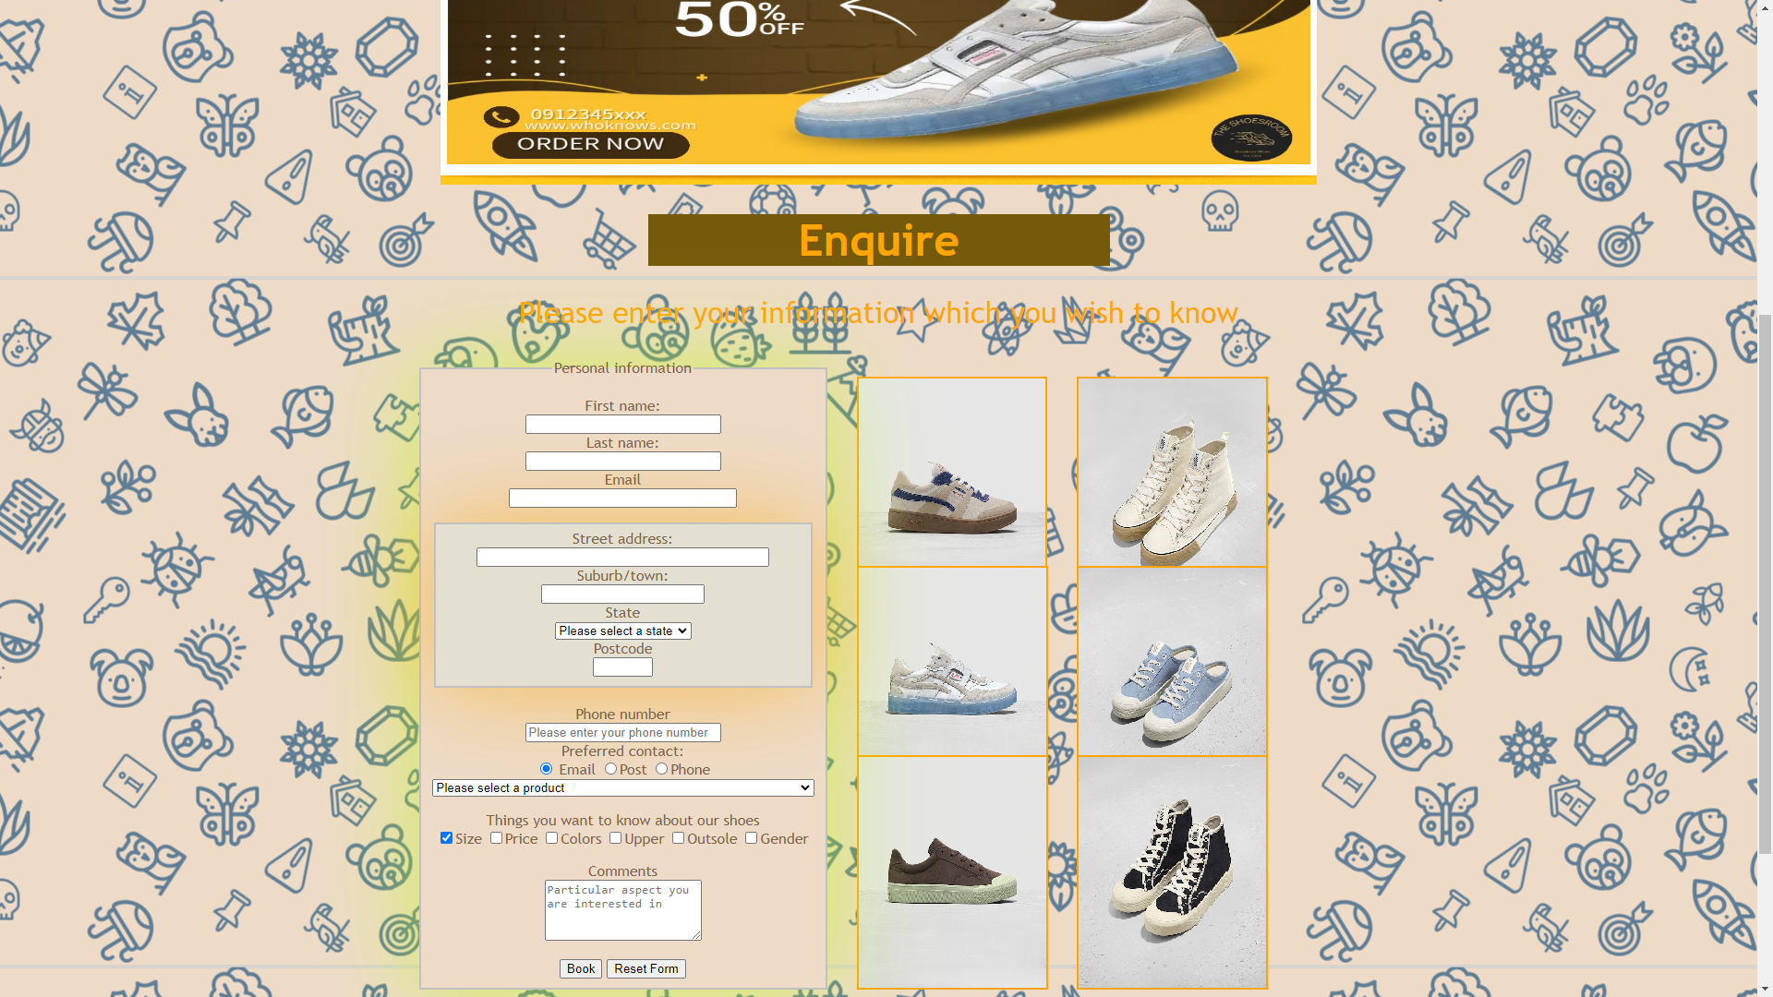

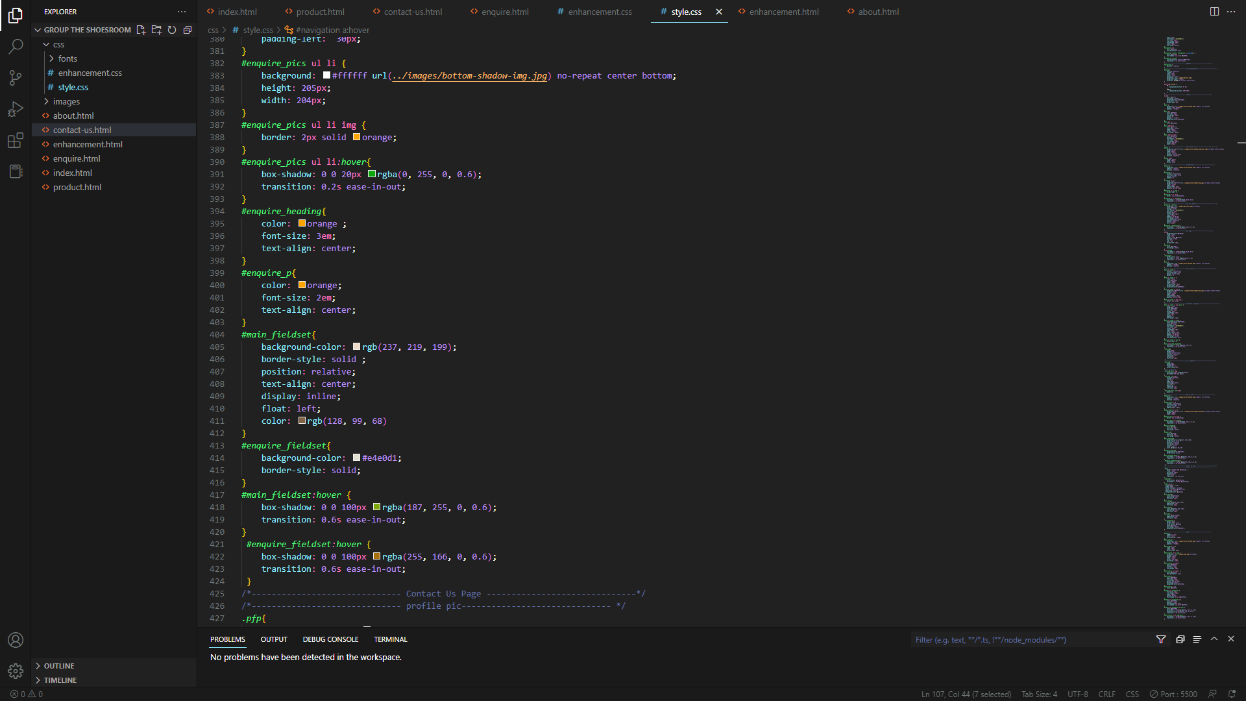

The last page is our contact us page which also has the hovering effect over our profile picture classified as "pfp"

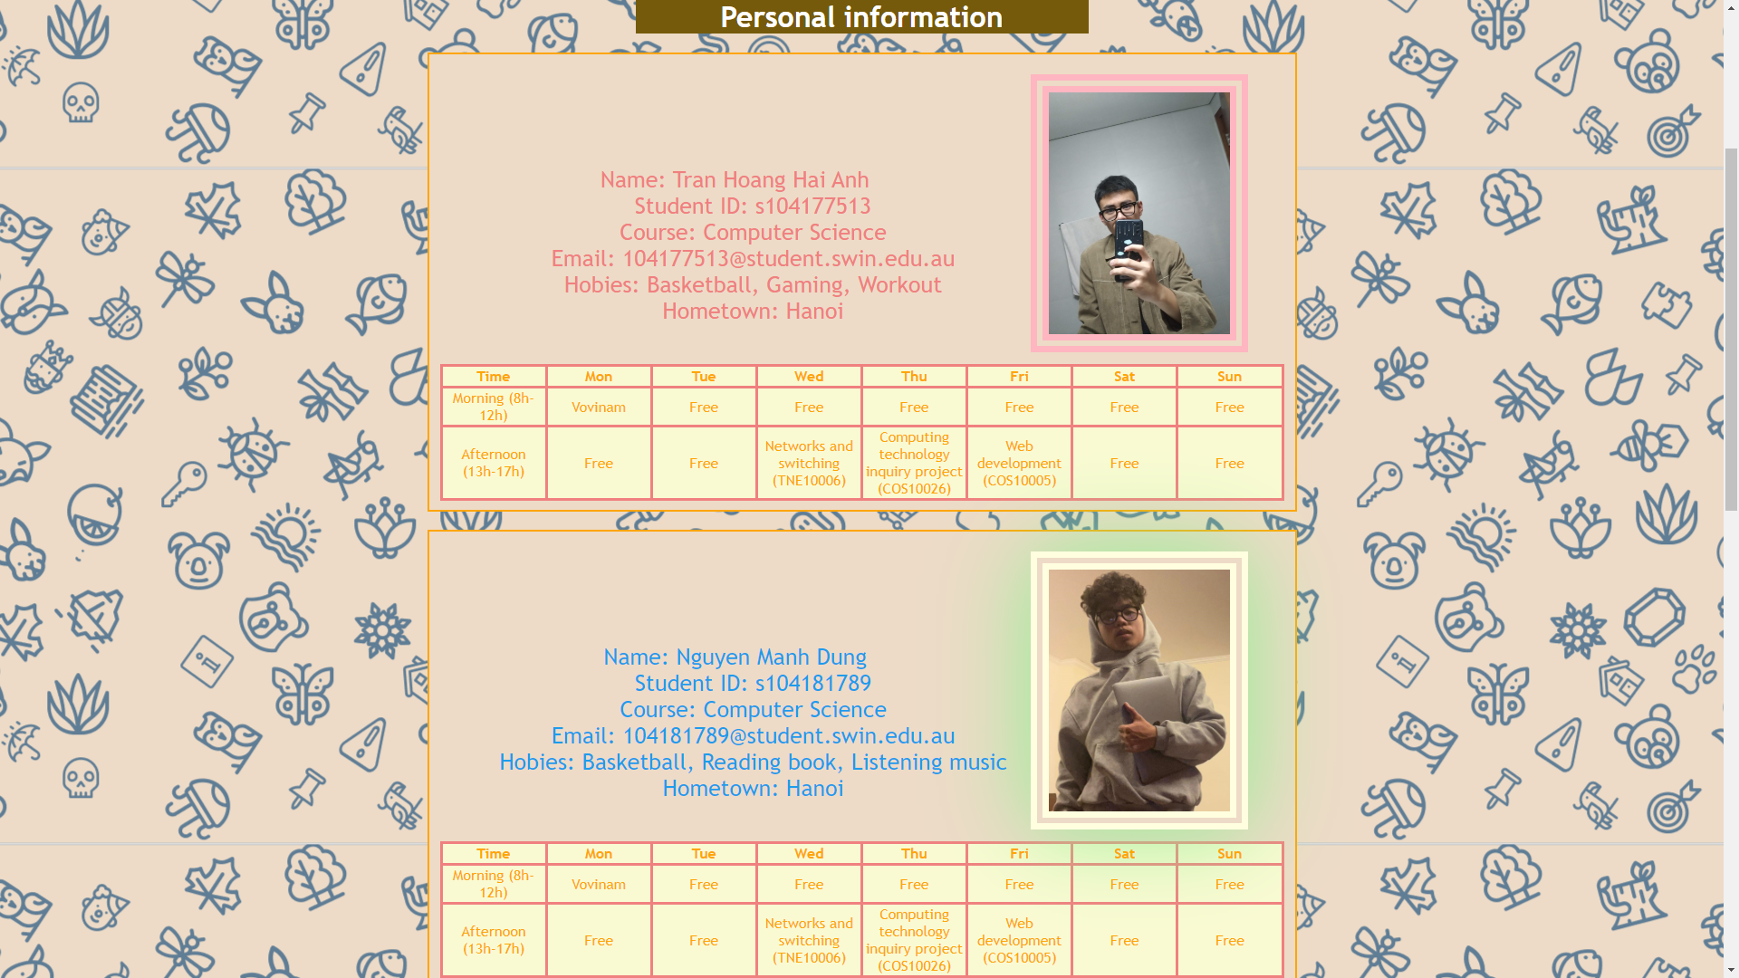

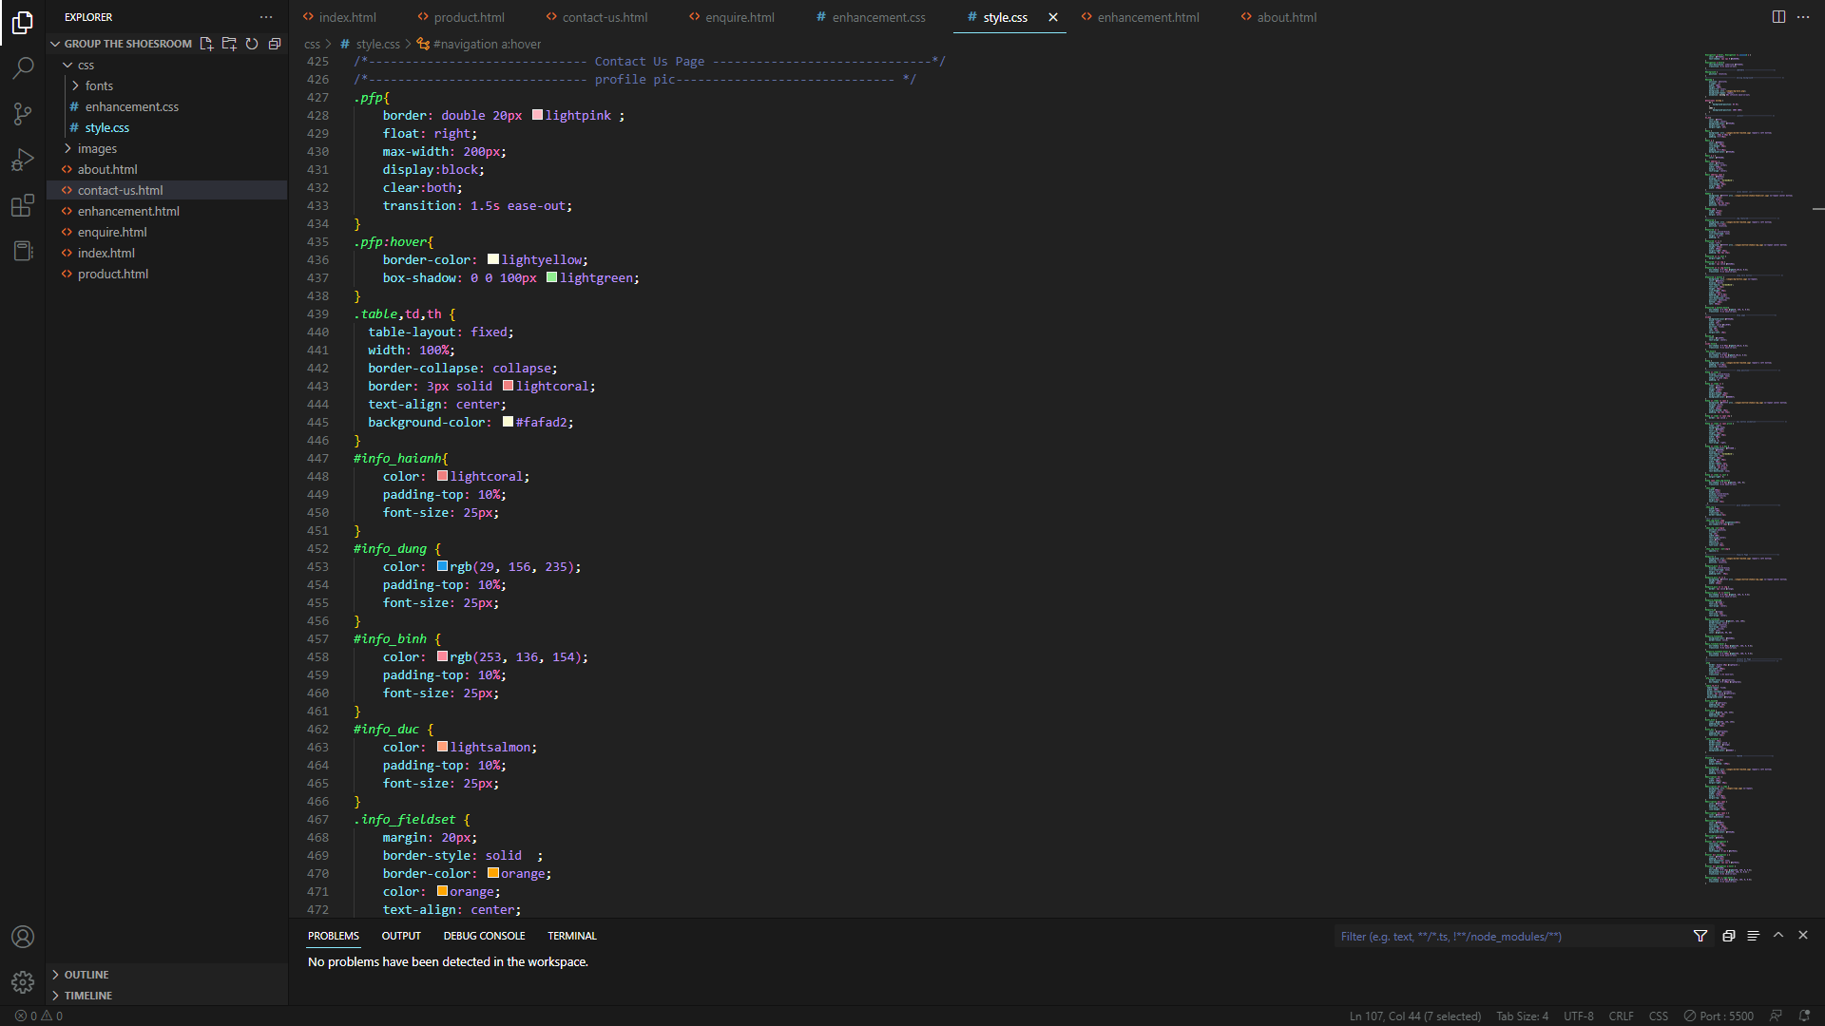

To create a good-looking table, our team used css like border, text-align, and bg color for it. We use id for our info to customize each color for each of our members. For the footer part, we mainly used positioning markups like margin, padding, width, height, and text size to create a neat footer part that won't look unorganized or uncentered.

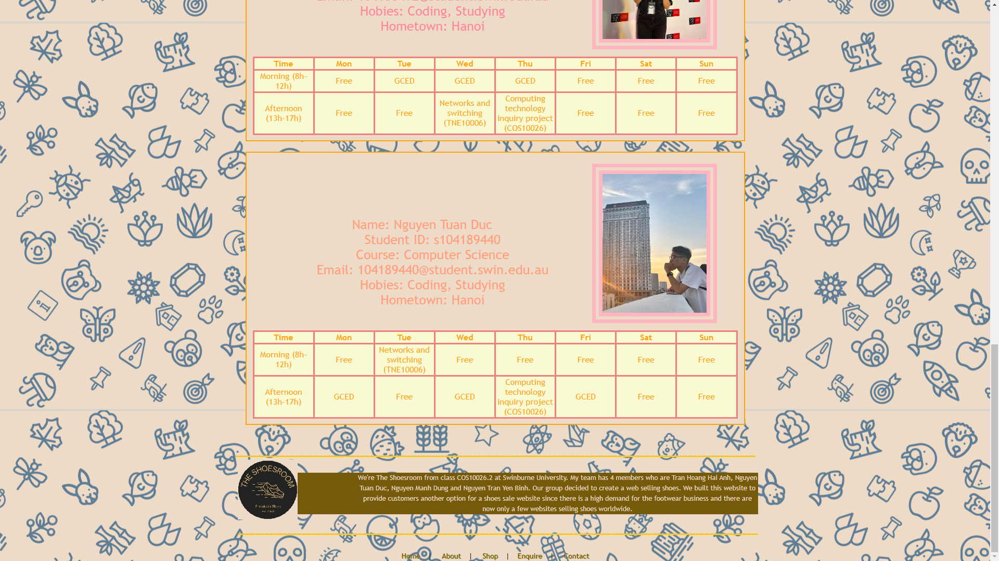

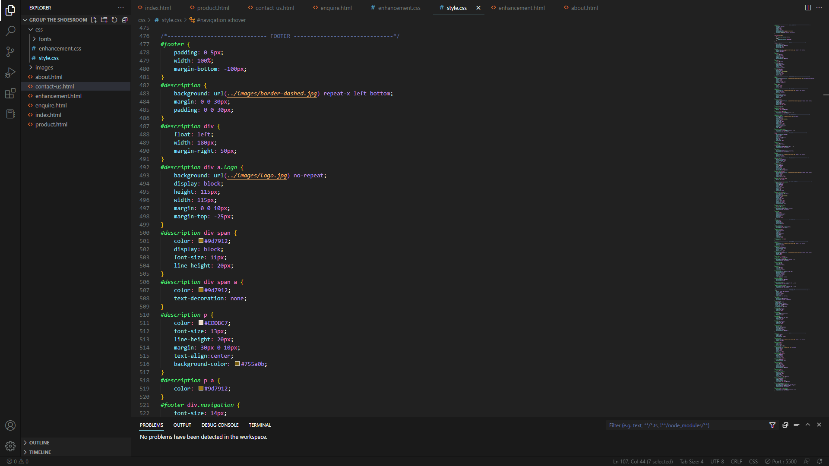

**5.KEY FEATURE**

Our website has a great appearance and some amazing effects such as a moving background, hovering effect, etc. It is designed to be user-friendly as well as simple but informative style. Our websites have specific information about our shoes, a well-designed form, and a colorful contact us page which expresses each of our member's personality.

**6.MY CONTRIBUTION**

I did a lot of work for our websites, from fixing bugs, changing appearance, and adding content,... The enquire page and contact us page were done by me, many effects on this page were done mainly by me and Nguyen Manh Dung. I spent a lot of time changing many lines of code, fixing the margin, and adding images as well as creating the enhancement page to HTML from a text by Nguyen Tuan Duc.

**7.CONCLUSION**

This report describes in detail our website content and style in both academic and technical ways. It introduces the purpose of each page, how we applied CSS to our HTML website, and some of our main and unique features as well as my contribution to my team. For further improvements, I would like to have a website with many more great and astonishing CSS animations which can easily catch the attention of customers.